Amazon Books
- Overview of the Data set
The Amazon book sale data set is a comprehensive collection of information related to books available for sale on the Amazon platform. It consists of 7 columns and 550 rows, each containing valuable data points about various aspects of the books. The key columns in the dataset include the following:
Name: The title or name of the book.
Author: The author or authors of the book.
Reviews: The total number of reviews received for the book. Feedback and reviews provided by customers who have purchased and read the book
User Rating: The average rating given by users for the book.
Price: The price of the book.
Year: The year when the book was published.
Genre: The category or genre of the book which include Fiction and Non Fiction.
The extensive nature of the data set allows for comprehensive analysis and exploration of the book sale data on Amazon, enabling researchers, analysts, and book enthusiasts to gain insights into various aspects of the book market and trends.

ii. Overview of the Tools used for the Analysis and Visualization
The Tools used for this analysis are SQL Server Management Studio(SSMS) and Power BI. The SQL has been used for analyzing the data and the Power BI used for Visualization of data .
- SQL Queries(SSMS):
When working with the Amazon book sale dataset, SQL (Structured Query Language) is used to query and manipulate the data. Some common SQL queries that been used to run on the dataset for analysis which includes SELECT statement with the combination of Aggregate functions like Min, Max, Sum, Count, order by, Group by and many more constrains
- Power BI Visualizations:
Power BI provides a wide range of visualizations to present data from the Amazon book sale dataset in a visually appealing and interactive manner. Some commonly used visualizations for this dataset include:
Bar Charts: Bar charts used to compare book sales or user ratings across different genres, authors, or years. They provide a clear visual representation of the data and allow users to easily identify trends and patterns.
Line Charts: Line charts used to track sales over time. Users can visualize the sales of books over different years, identifying any upward or downward trends.

Pie Charts: Pie charts used to represent the distribution of books across various genres. They provide a quick overview of the relative proportions of different categories.

Analysis of Amazon Books
Q1. Categorize the 550 books to fiction and non-fiction.
Answer:
i. select name, genre from amazon_csv where genre = 'Fiction';
ii. select name, genre from amazon_csv where genre = 'Non Fiction;
iii. SELECT
name AS Title,
author, genre,
row_number() OVER (PARTITION BY genre) AS row
FROM Amazon_csv;

iv. select count(case when genre='Fiction' then 1 end) Fiction,
count(case when genre='Non Fiction' then 1 end) NonFiction
from [dbo].[Amazon_csv] group by genre;
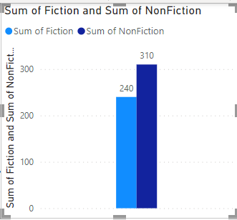

Observation :
Fiction count = 240
Non-Function = 310

Q2. Query the top 50 best sellers and show the following:
a. Title of Book
b. Author
c. Year
d. Review
Answer:
- select top(50) name, author, year,reviews from amazon_csv order by reviews desc;
- with cnt1(name, author,review,year) as
(
select top(50) name,author,reviews,Year from Amazon_csv order by reviews
)
select year, count(*) from cnt1 group by year;
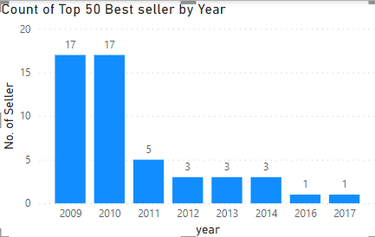
Observation:
* The range of top 50 reviews from 87841 to 26234
* Year includes 2010 to 2019
* Year excludes 2009

Q3. Query the books which have a rating greater than 4 released last 2019.
Answer:
- select name,user_rating, year from amazon_csv where user_rating>4 and year=2019;
2. with cnt2(name,user_rating,year) as
(
select name,user_rating, year from amazon_csv where user_rating>4 and year=2019
)
select user_rating, count(name) from cnt2 group by user_rating;
3. select avg(user_rating)from amazon_csv where user_rating>4 and year=2019;
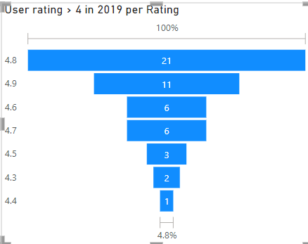
Observation:
* Total count rows have a rating >4 released in the year 2019=50
* Average rating in the year = 4.74

Q4. Query the books which have a rating greater than 4.5 in Fiction per year .
Answer:
select year, count(name) from Amazon_csv where genre='Fiction' and User_Rating >4.5 group by year;
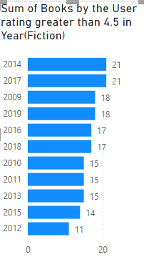

Q5. Query the books which have a rating greater than 4.5 in Fiction per year .
Answer:
select year, count(name) from Amazon_csv where genre='Non Fiction' and User_Rating >4.5 group by year;

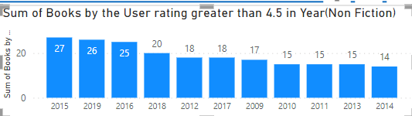

Q6. Sum of Reviews per year
Answer:
select year, sum(reviews) from Amazon_csv group by year;

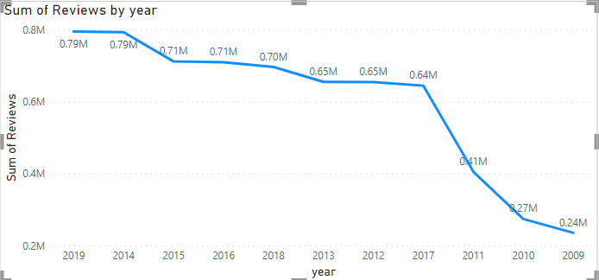
Year Sum of Reviews
2009 | 235506
2010 | 273981
2011 | 405041
2012 | 654546
2013 | 654907
2014 | 792997
2015 | 711669
2016 | 709800
2017 | 644420
2018 | 696521
2019 | 794917

Q7. Number of Titles with reviews < 10K per year
Answer:
select year, count(name) from Amazon_csv where reviews <1000 group by year;

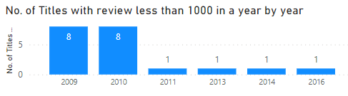

Q8. Number of Titles with reviews < 10K per year
Answer:
select year,count(name) from Amazon_csv where price between 10 and 15 group by year;

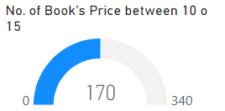

Q9. Number of Titles with reviews < 10K per year
Answer:
select year, count(name) from Amazon_csv where reviews <5000 and price>15 and genre='Fiction' group by year;
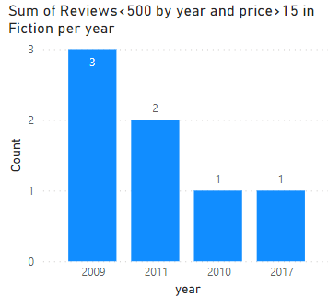

Q10. Number of Book with minimum reviews and minimum price per year
Answer:
select year, count(name) from Amazon_csv where reviews = (select min(reviews) from Amazon_csv) or Price=(select min(price) from Amazon_csv) group by year;

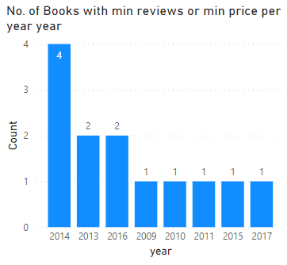

Q11. Number of Book with minimum price in Fiction per year
Answer:
select year, count(name) from Amazon_csv where Price=(select min(price) from Amazon_csv) and genre ='Fiction' group by year;

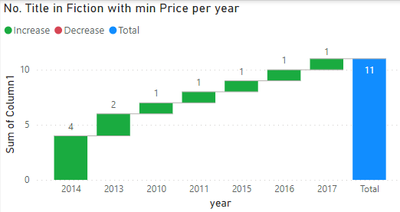

Q12. Number of Book with minimum price in Fiction per year
Answer:
select year,count(name) from Amazon_csv where price = any(select price from Amazon_csv where reviews=87841) group by year;

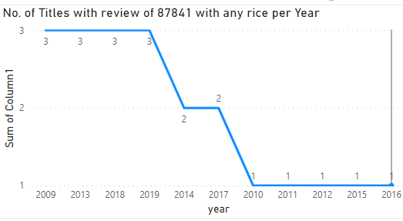

Q13. Total Book in Fiction per Year
Answer:
select year, count(genre) from Amazon_csv where genre ='Fiction' group by year;

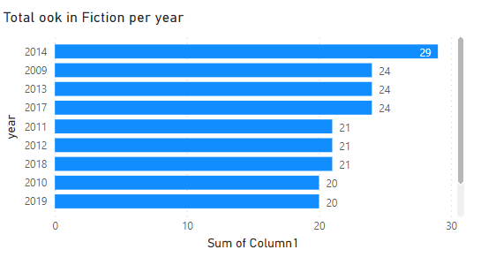

Q14. Total Book in Non Fiction per Year
Answer:
select year, count(genre) from Amazon_csv where genre ='Non Fiction' group by year;

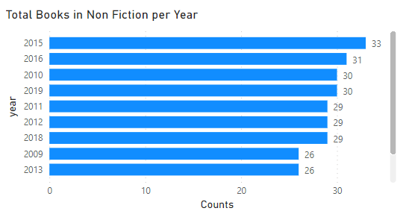

Q15. Total Book in Non Fiction per Year
Answer:
select year, count(name) from Amazon_csv where reviews = (select max(reviews) from Amazon_csv) or Price=(select max(price) from Amazon_csv) group by year;

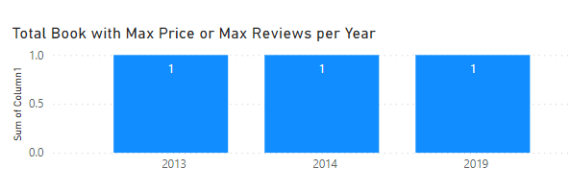
Observarion:
One book with Maximum reviews and price in 2013,14 and 19.

